XXXX Systems Limited

TECHNICAL PACKAGE
OF

FLOAT CUM BOOST CHARGER
(SUITABLE FOR VRLA/NI-CD/PLANTE/TUBULAR BATTERIES)

Customer :

Project :

P. O. No. :

S. O. No. :

Line No. :

XXXX SYSTEMS LIMITED

CONTENTS

SL.NO DESCRIPTION

- GENERAL DESCRIPTION

- TECHNICAL SPECIFICATION OF THE BATTERY CHARGER

- LOGIC SHEET OF THE BATTERY CHARGER

4. FUNCTIONAL BLOCK DIAGRAM

- XXXX STANDARD SUB-VENDOR LIST

- SCHEMATIC DRAWINGS

- BILL OF MATERIALS

- DIMENSIONAL DRAWINGS

- BATTERY DETAILS

GENERAL DESCRIPTION

The Battery Charger is a Rectifier Unit which works on 3-phase AC Input Power Supply and gives required DC Voltage as Output, delivering certain amount of power as demanded by the application. Conventionally this kind of rectifier unit is controlled manually and is analog control. However, the analog portion of the control circuit has been replaced here in micro charger with a micro-controller. Advanced micro-controller has been selected for this application and this controller section provides accuracy of operations. Block diagram of one such rectifier unit is shown below in Fig. 1.

FUNCTIONAL BLOCK DIAGRAM OF
MICROBASED RECTIFIER UNIT
AC MAINS
(3 PHASE)
RECTIFIER
OUTPUT
TRANSFORMER
SCR BRIGE
LC FILTER
R
Y
B
MICRO BOARD
SENSING BOARD
CONTROL CIRCUIT
FIRING BOARD
Fig. 1

Rectifier unit consists of a transformer to bring the input voltage to a required level and also to provide isolation between input and output. The secondary of the isolation transformer is fed to SCR Bridge. Initially SCRs will be fired slowly for DC soft start and controls the phase angle depending upon the output voltage of the charger. The rectified DC is connected to filter section which in turn filters out all harmonics and provide DC voltage with low ripple content.

Charger mode of operation can be selected through LCD. The charger will work in FLOAT, BOOST and AUTO modes. In any mode, monitoring and controlling happens through micro board. Charger feedback signals are fed to micro board based on which it generates reference signal. Micro board is provided at front panel to display charger parameters, load parameters and battery parameters in LCD. Micro board is having LED indicators for different operating conditions like FLOAT ON, BOOST ON, CHARGER ON, MAINS ON, CHARGER OVER VOLTAGE, CHARGER UNDER VOLTAGE, BATTERY FUSE FAIL, SCR FUSE FAIL, LOAD UNDER VOLTAGE, LOAD OVER VOLTAGE etc. Based on faulty condition, appropriate LED glows & activates audio alarm. This audio alarm can be
disabled or silenced by setting buzzer in LCD set parameters menu. However, indicating LED will be glowing continuously until the fault is rectified.

The firing board receives the voltage and current reference signals from micro board. It generates SCR firing signals based on reference and feedback signals.

Sensing board senses different faulty conditions like SCR FUSE FAIL, EARTH FAULT etc. and send it to micro board for alarms generation. Sensing board is also having potential free contacts for alarm conditions.

PRINCIPLE OF OPERATION

During normal operation, Float cum Boost Charger works as Float Charger and takes care of load and battery float charging requirements.

Float cum Boost Charger has two modes of operation “AUTO” & “MANUAL”.

Under AUTO MODE, Float cum Boost Charger can either act as an Auto Float Charger or an Auto Boost Charger depending on the Battery current requirement.

Manual intervention is not required when the Float cum Boost Charger is selected to AUTO MODE.

Float cum Boost Charger is provided with provision of MANUAL FLOAT and MANUAL BOOST Modes in which battery can be charged either in FLOAT or BOOST by manual selection.

On failure of AC Mains Supply to Float cum Boost Charger or if Float cum Boost Charger itself fails, Battery starts supplying to the load.

Once the AC Mains Supply to FCBC restores or if failed FCBC is rectified, FCBC switches over to Float Mode or Boost Mode based on the Battery charging requirements if the charger is kept in AUTO mode of operation.

TECHNICAL SPECIFICATION OF THE BATTERY CHARGER

SCHEME : FLOAT CUM BOOST CHARGER

TYPE : FULL WAVE FULL CONTROLLED

TYPE OF BATTERY : VRLA / NI-CD / PLANTE / TUBULAR

INPUT

- Three phase Input : 415V AC ±10% (Three Phase, Three/Four Wire)
- Frequency : 50Hz ± 5%

OUTPUT

- Battery Nominal Voltages : 24VDC / 48VDC / 110VDC / 220VDC
- Output Currents : 25A / 50A / 75A / 100A / 125A / 150A
- Ripple : 2% RMS (Without Battery connected)
- Efficiency : > 80%
- Operating Voltage Ranges for various Batteries with various Voltages:

Battery Type | VRLA |  |  |  | NI-CD |  |  |  | PLANTE / TUBULAR
No. of Cells | 12 | 24 | 55 | 110 | 20 | 40 | 87 | 174 | 12 | 24 | 55 | 110
Voltages | 24 | 48 | 110 | 220 | 24 | 48 | 110 | 220 | 24 | 48 | 110 | 220
Float  Voltage | 27 | 54 | 123.75 | 247.5 | 28 | 56 | 121.8 | 243.6 | 27.0 | 54.0 | 123.75 | 247.5
Boost Voltage | 27.6 | 55.2 | 126.5 | 253 | 34 | 68 | 147.9 | 295.8 | 31.8 | 63.6 | 145.75 | 291.5
Equalize Voltage | --- | --- | --- | --- | --- | --- | --- | --- | 33 | 66 | 151.25 | 302.5
Load Voltage | 27.6 | 55.2 | 126.5 | 253 | 34 | 68 | 147.9 | 295.8 | 33 | 66 | 151.25 | 302.5

VOLTAGE REGULATION

Charger output is ±1% of the set value in the following conditions in set mode
(FLOAT /BOOST/AUTO)

Load variation : 10-100%
Line variation : ± 10%
Frequency Variations : ± 5%
Temperature Variations : 0 ºC to +50 ºC

INDICATIONS

Cluster LED Lamps will be provided for “AC Mains ON (R, Y, B)” condition.

The following indications will be provided in the charger system by 5mm LEDs:

- AC Mains ON : Green LED
- Charger ON : Green LED
- Float ON : Green LED
- Boost ON : Amber LED
- AC Mains Fail : Red LED
- Charger Over Voltage : Red LED

- Charger Under Voltage : Red LED
- SCR Fuse Fail : Red LED
- Battery Fuse Fail : Red LED
- Battery Earth Fault : Red LED
- Charger Fail : Red LED
- Group Alarm : Red LED
- Load Under Voltage : Red LED
- Load Over Voltage : Red LED
- Battery Reverse Polarity : Red LED (provided at Battery Termination)

DISPLAY

The following parameters will be displayed on LCD:

- AC Input Voltage either Line to Line or Line to Neutral
- AC Input Current in each phase
- Charger Output Voltage
- Charger Output Current
- Battery Voltage
- Battery Charge/Discharge Current
- Load Voltage
- Load Current
- Charger ON/OFF
- Alarms

ALARMS WITH BUZZER

- AC Mains Fail/Out of Limit : Both LCD and LED Indication
- SCR Fuse Fail : Both LCD and LED Indication
- Battery Fuse Fail : Both LCD and LED Indication
- Charger Fail : Both LCD and LED Indication
- Charger Under Voltage : Both LCD and LED Indication
- Charger Over Voltage : Both LCD and LED Indication
- Battery Earth Fault : Both LCD and LED Indication
- Group Alarm : LED Indication only
- Load Under Voltage : Both LCD and LED Indication
- Load Over Voltage : Both LCD and LED Indication
- DC Overload : LCD only
- Charger Over Temperature: LCD only
- AC I/P CB Trip/OFF : LCD only
- DC O/P CB Trip/OFF : LCD only
- Filter Fuse Fail : LCD only

POTENTIAL FREE CONTACTS

For following PFCs will be provided:

- Float ON
- Boost ON
- Rectifiers Fuse Fail
- Charger Fail
- Charger Under Voltage

- Charger Over Voltage
- Battery Earth Fault
- Group Alarm

PROTECTIONS

The following protections will be provided:

- AC Input Circuit Breaker
- Fast acting Semiconductor Fuses for SCR Bridge
- DC Over Voltage Cutback / Shut Down
- DC Overload
- DC Output Circuit Breaker
- Battery Input Fuses
- Battery Current Limit
- Charger Current Limit
- Blocking Diode

CONTROLS & SWITCHES

- AC Input ON/OFF Circuit Breaker
- DC Output ON/OFF Circuit Breaker
- Battery Input Fuses
- Socket ON/OFF Switch
- Heater ON/OFF Switch
- Door Lamp ON/OFF Push Button
- Push Buttons: Menu; Increment; Decrement; Enter & Back

ENVIRONMENTAL STABILITY

Operating Temperature : -5 ºC to +50 ºC
Storage : 25 ºC to +70 ºC
Relative Humidity : 0-95% (Non-condensing)
Noise Level : < 70 dB (A)

SPECIAL FEATURES

- Auto Phase Reversal Operation
- Soft Start on DC side
- Class-F Insulation with Class-F Temperature Limits for all Magnetics
- Automatic Voltage Regulation using Digital Control Logic
- Filter Circuit to Limit Ripple
- Charger Current Limiting
- Battery Current Limiting
- Automatic Float to Boost changeover based on current drawn by Battery
- Automatic Boost to Float changeover based on Current or Voltage.
- Anti-condensation Heater with Thermostat Control
- Blocking Diode Short Sensing
- RS-485, 4-Wire Communication with MODBUS Protocol (communication cable from Battery Charger System to user equipment like SCADA is not in XXXX scope)

GENERAL

Cabinet : Freestanding Cabinet; Floor Mounting Type,
Sheet Steel Construction; Easy for Installation and
Maintenance; Components are accessible from Front
& Rear; Cable entry at Front Bottom of the Cabinet

Protection : IP – 42

Paint Shade : As per the Dimensional Drawings enclosed

CRCA Sheet Thickness : As per the Dimensional Drawings enclosed

Nature of Cooling : Natural Air Cooling

Dimensions in mm : As per the Dimensional Drawings enclosed

* * * * *

LOGIC SHEET OF THE BATTERY CHARGER

System Conditon | Charger Mode | FCBC | Battery | Load
AC Mains Available & Battery is healthy | AUTO | ON | On Float | FCBC will supply the Load and Float Voltage will reflect on Load
AC Mains Available & Battery is in Discharged Condition | AUTO | ON | On Boost | FCBC will supply the Load and Boost Voltage will reflect on Load
AC Mains Available | FLOAT | ON | On Float irrespective of it’s condition | FCBC will supply the Load and Float Voltage will reflect on Load
AC Mains Available | BOOST | ON | On Boost irrespective of it’s condition | FCBC will supply the Load and Boost Voltage will reflect on Load
AC Mains Fail / FCBC Fail | ANY MODE | OFF | On Discharge | Battery will supply to Load

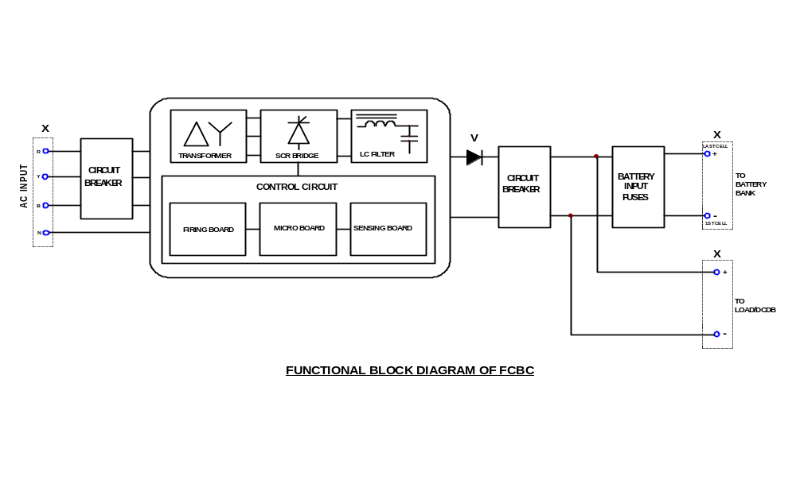

XXXX STANDARD SUB-VENDOR LIST
SL. NO. | ITEM / COMPONENT | SUB-VENDOR / SUPPLIER
 | AC CONTACTOR (POWER & CONTROL) | ABB / L&T / C&S
 | DC CONTACTOR (POWER & CONTROL) | ABB / L&T / C&S
 | COPPER BUS BAR | CUBEX TUBINGS / BHAGYA NAGAR INDIA LIMITED
 | ALUMINUM BUS BAR | PERFECT MACHINES CENTRE / GLOBAL ALUMINUM / MAHA SAI
 | CONTROL SWITCH | SALZER (L&T) / RG KESHWANI / RECOM
 | CABLE / WIRE | ANY IS OR BIS APPROVED MAKES
 | ELECTROLYTIC CAPACITOR | ALCON
 | FUSE (HRC / HBC / SEMICONDUCTOR) & FUSE BASE | BUSSMANN (EATON)
 | FUSE (GLASS) | PROTECTRON
 | FUSE BASE FOR GLASS FUSE | CONNECTWELL
 | ALARM ANNUNCIATOR  (FACIA DISPLAY UNIT) | SUN INDUSTRIAL AUTOMATION & SOLUTIONS / SECO
 | HEAVY DUTY SWITCH | SALZER (L&T) / KAYCEE
 | HEAT SINK | PERFECT MACHINES CENTRE / GLOBAL ALUMINUM / MAHA SAI
 | SPACE HEATER | ENCORE / PYRO
 | INDICATING LAMP  (CLUSTER LED TYPE) | ESBEE (L&T) / C&S / SECO
 | LED | SANKEN / KWALITY
 | ANALOG / DIGITAL METER | BEEMET / RISHABH / AE / ELMEASURE
 | METAL OXIDE VARISTOR (MOV) | EPCOS
 | OLR (THERMAL OVER LOAD RELAY) | ABB / L&T / C&S
 | CONTROL CARD (POPULATED PCB) | XXXX
 | PUSH BUTTON | RECOM / RG KESHWANI / TEKNIC / SECO
 | POTENTIOMETER | POTEL / BOURNS / PANKAJ / SURAJ
 | POLYESTER CAPACITOR | EL-CI-AR
 | PANEL / CABINET | XXXX

SL. NO. | ITEM / COMPONENT | SUB-VENDOR / SUPPLIER
 | SHUNT | BEEMET / RISHABH
 | TOGGLE SWITCH | RG KESHWANI / RECOM
 | THYRISTOR (SCR) | SEMIKRON / HIRECT / RIR / NAINA
 | POWER DIODE | SEMIKRON / HIRECT / RIR / NAINA
 | CONTROL DIODE | VISHAY / MIC / KHEL / PHILIPS
 | TERMINAL BLOCK | ELMEX
 | THERMAL SWITCH | UTILITY APPLIANCES
 | TRANSFORMER / CHOKE | XXXX
 | WIRE WOUND / CF / MF RESISTORS | DEL / PEC / VEPL / WATTS
 | DOOR LAMP | PHILIPS / WIPRO / BAJAJ / HAVELLS
 | DOOR LAMP HOLDER | ANCHOR / SURAJ / ELICO
 | FUSE TRIP INDICATOR | BUSSMANN (EATON)
 | VOLTAGE & CURRENT TRANSDUCERS | RISHABH / ELMEASURE
 | FAN | EBM / REXNORD / SUNON
 | SWITCH FUSE UNIT | L&T
 | CURRENT TRANSFORMER (CT) | KALPA
 | MCCB (AC & DC) | C&S / SCHNEIDER
 | MCB (AC & DC) | LEGRAND / SCHNEIDER / C&S / SIEMENS
 | TIMER | GIC (L&T)
 | AUXILIARY RELAY | PLA / OEN
 | LED HOLDER | LALWANI
 | DOOR LAMP PUSH BUTTON | SURAJ / ELICO
 | ROTARY & CAM OPERATED SWITCHES | SALZER (L&T) / KAYCEE / RECOM
 | BUZZER | METRONIX
 | CONNECTORS & CRIMPS | TYCO / WAGO / MOLEX / CONNECWELL

